Assignment Objectives:
Assignment:
----------------------
Business Scenario
A company is migrating its infrastructure to AWS.
They have the following requirements:
"We need a highly available AWS environment in which Internet-facing infrastructure is separated from internal infrastructure. Compute resources must automatically scale, the database must not be Internet accessible, and private servers should access S3 without traversing the public Internet."

Required Architecture:
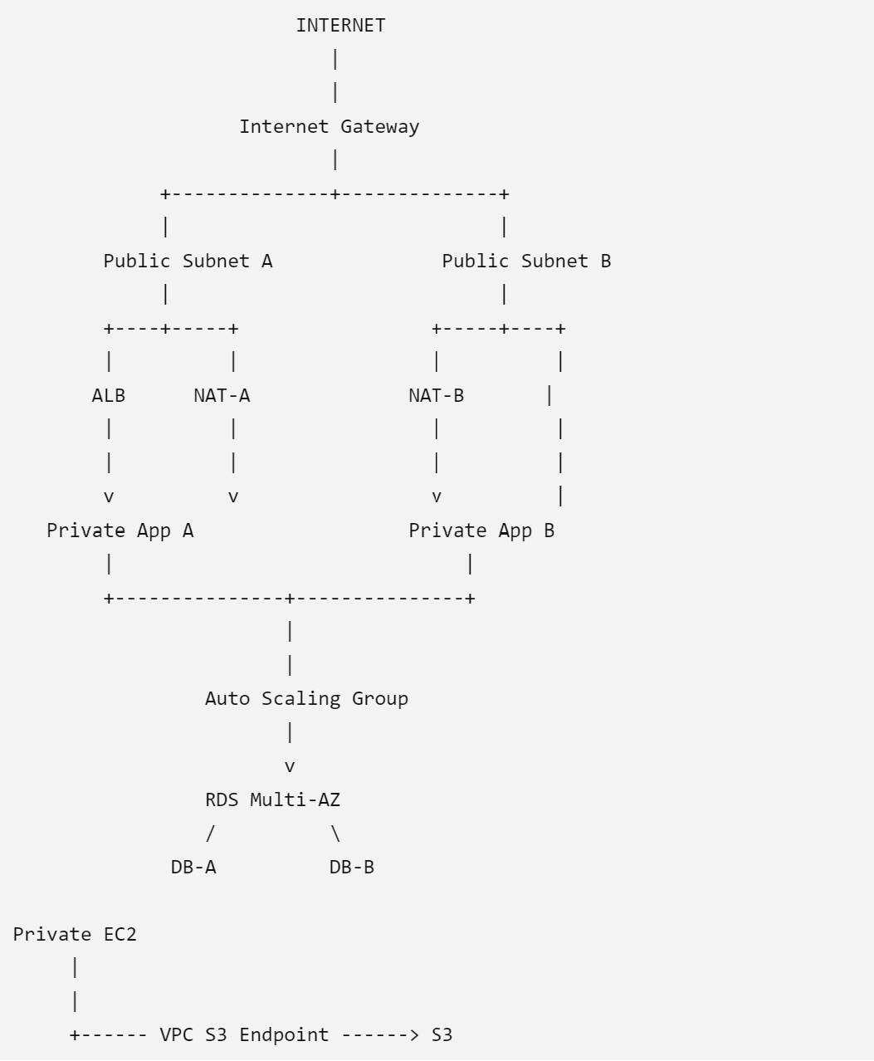

Student Requirements
Students are given only the following requirements.
They must determine the implementation themselves.
Requirement 1 — Network
Create a VPC with:
- 2 AZs
- 2 public subnets
- 2 private application subnets
- 2 private database subnets

Requirement 2 — Internet Access
Internet-facing resources must be reachable from the Internet.
Private resources must not have public IP addresses.

Requirement 3 — Private Outbound Access
Private EC2 instances need outbound Internet connectivity.
Requirement 4 — Load Balancing
Create an:
Application Load Balancer
The ALB must:
- Be Internet-facing.
- Use both public subnets.
- Have a target group.
- Distribute traffic to private EC2 instances.

Requirement 5 — Auto Scaling
Create an Auto Scaling Group.
Configuration:
Minimum: 2
Desired: 2
Maximum: 4
Instances must be launched in:
Private-App-1
Private-App-2
The ASG must use a Launch Template.
Requirement 6 — Database
Create:
Amazon RDS MySQL
Requirements:
- Multi-AZ
- Private subnets
- No public access
- DB security group
- Automated backups enabled
The database must only accept connections from the application EC2 security group.
Requirement 7 — S3
Create an S3 bucket.
Requirements:
- Block public access.
- Enable versioning.
- No public bucket policy.
Private EC2 instances must access S3.
Important challenge
Students should not use the NAT Gateway for S3 traffic.
Requirement 8 — Security Groups
Students must create at least three security groups.
ALB-SG
Allow:
HTTP 80
HTTPS 443
Source: Internet
APP-SG
Allow:
HTTP 80
Source: ALB-SG
DB-SG
Allow:
MySQL 3306
Source: APP-SG
Students lose marks if they use:
0.0.0.0/0
for the database.
Requirement 9 — IAM
Create an EC2 IAM role.
The EC2 instances must access S3 using:
IAM Role
rather than:
AWS Access Key
AWS Secret Key
Students should demonstrate:
aws sts get-caller-identity
from an EC2 instance.
Then:
aws s3 ls
The instance should be able to access the designated S3 bucket.
Requirement 10 — Monitoring
Configure CloudWatch monitoring for:
EC2
CPUUtilization
StatusCheckFailed
ALB
HealthyHostCount
UnHealthyHostCount
RequestCount
RDS
CPUUtilization
DatabaseConnections
FreeStorageSpace
Create at least one CloudWatch alarm.

Deliverables:
- Complete the above-mentioned tasks as a part of your Assignment 01.
- This is an Individual assignment.
- Find the Questions in the Assignment01_File in Assignment section.
Submission Details:
Please follow this path to submit the assignment on LMS (racelms.reva.edu.in). Sign in to LMS and go to dashboard (Topmost option on Left most side column) > Go to the channel –> Go to the post “Assignment & Assessments” > On the right-hand side of the screen you will see – “CAS05| SEM 01| Module 05 | Cloud Solutions Architecting| Papa Rao| Assignment 01…” > Click on “Start” > Upload your assignment.
- Zip the notebook, name it as Assignment1_Name and upload
- Kindly upload the assignment before the deadline.
- Since it is an individual assignment, the submission must be individual.
Date of submission in the LMS: 14th September 2026, 11:00 PM

